Professional Metal Detector
Operating Guide
Model ：GPX4500F

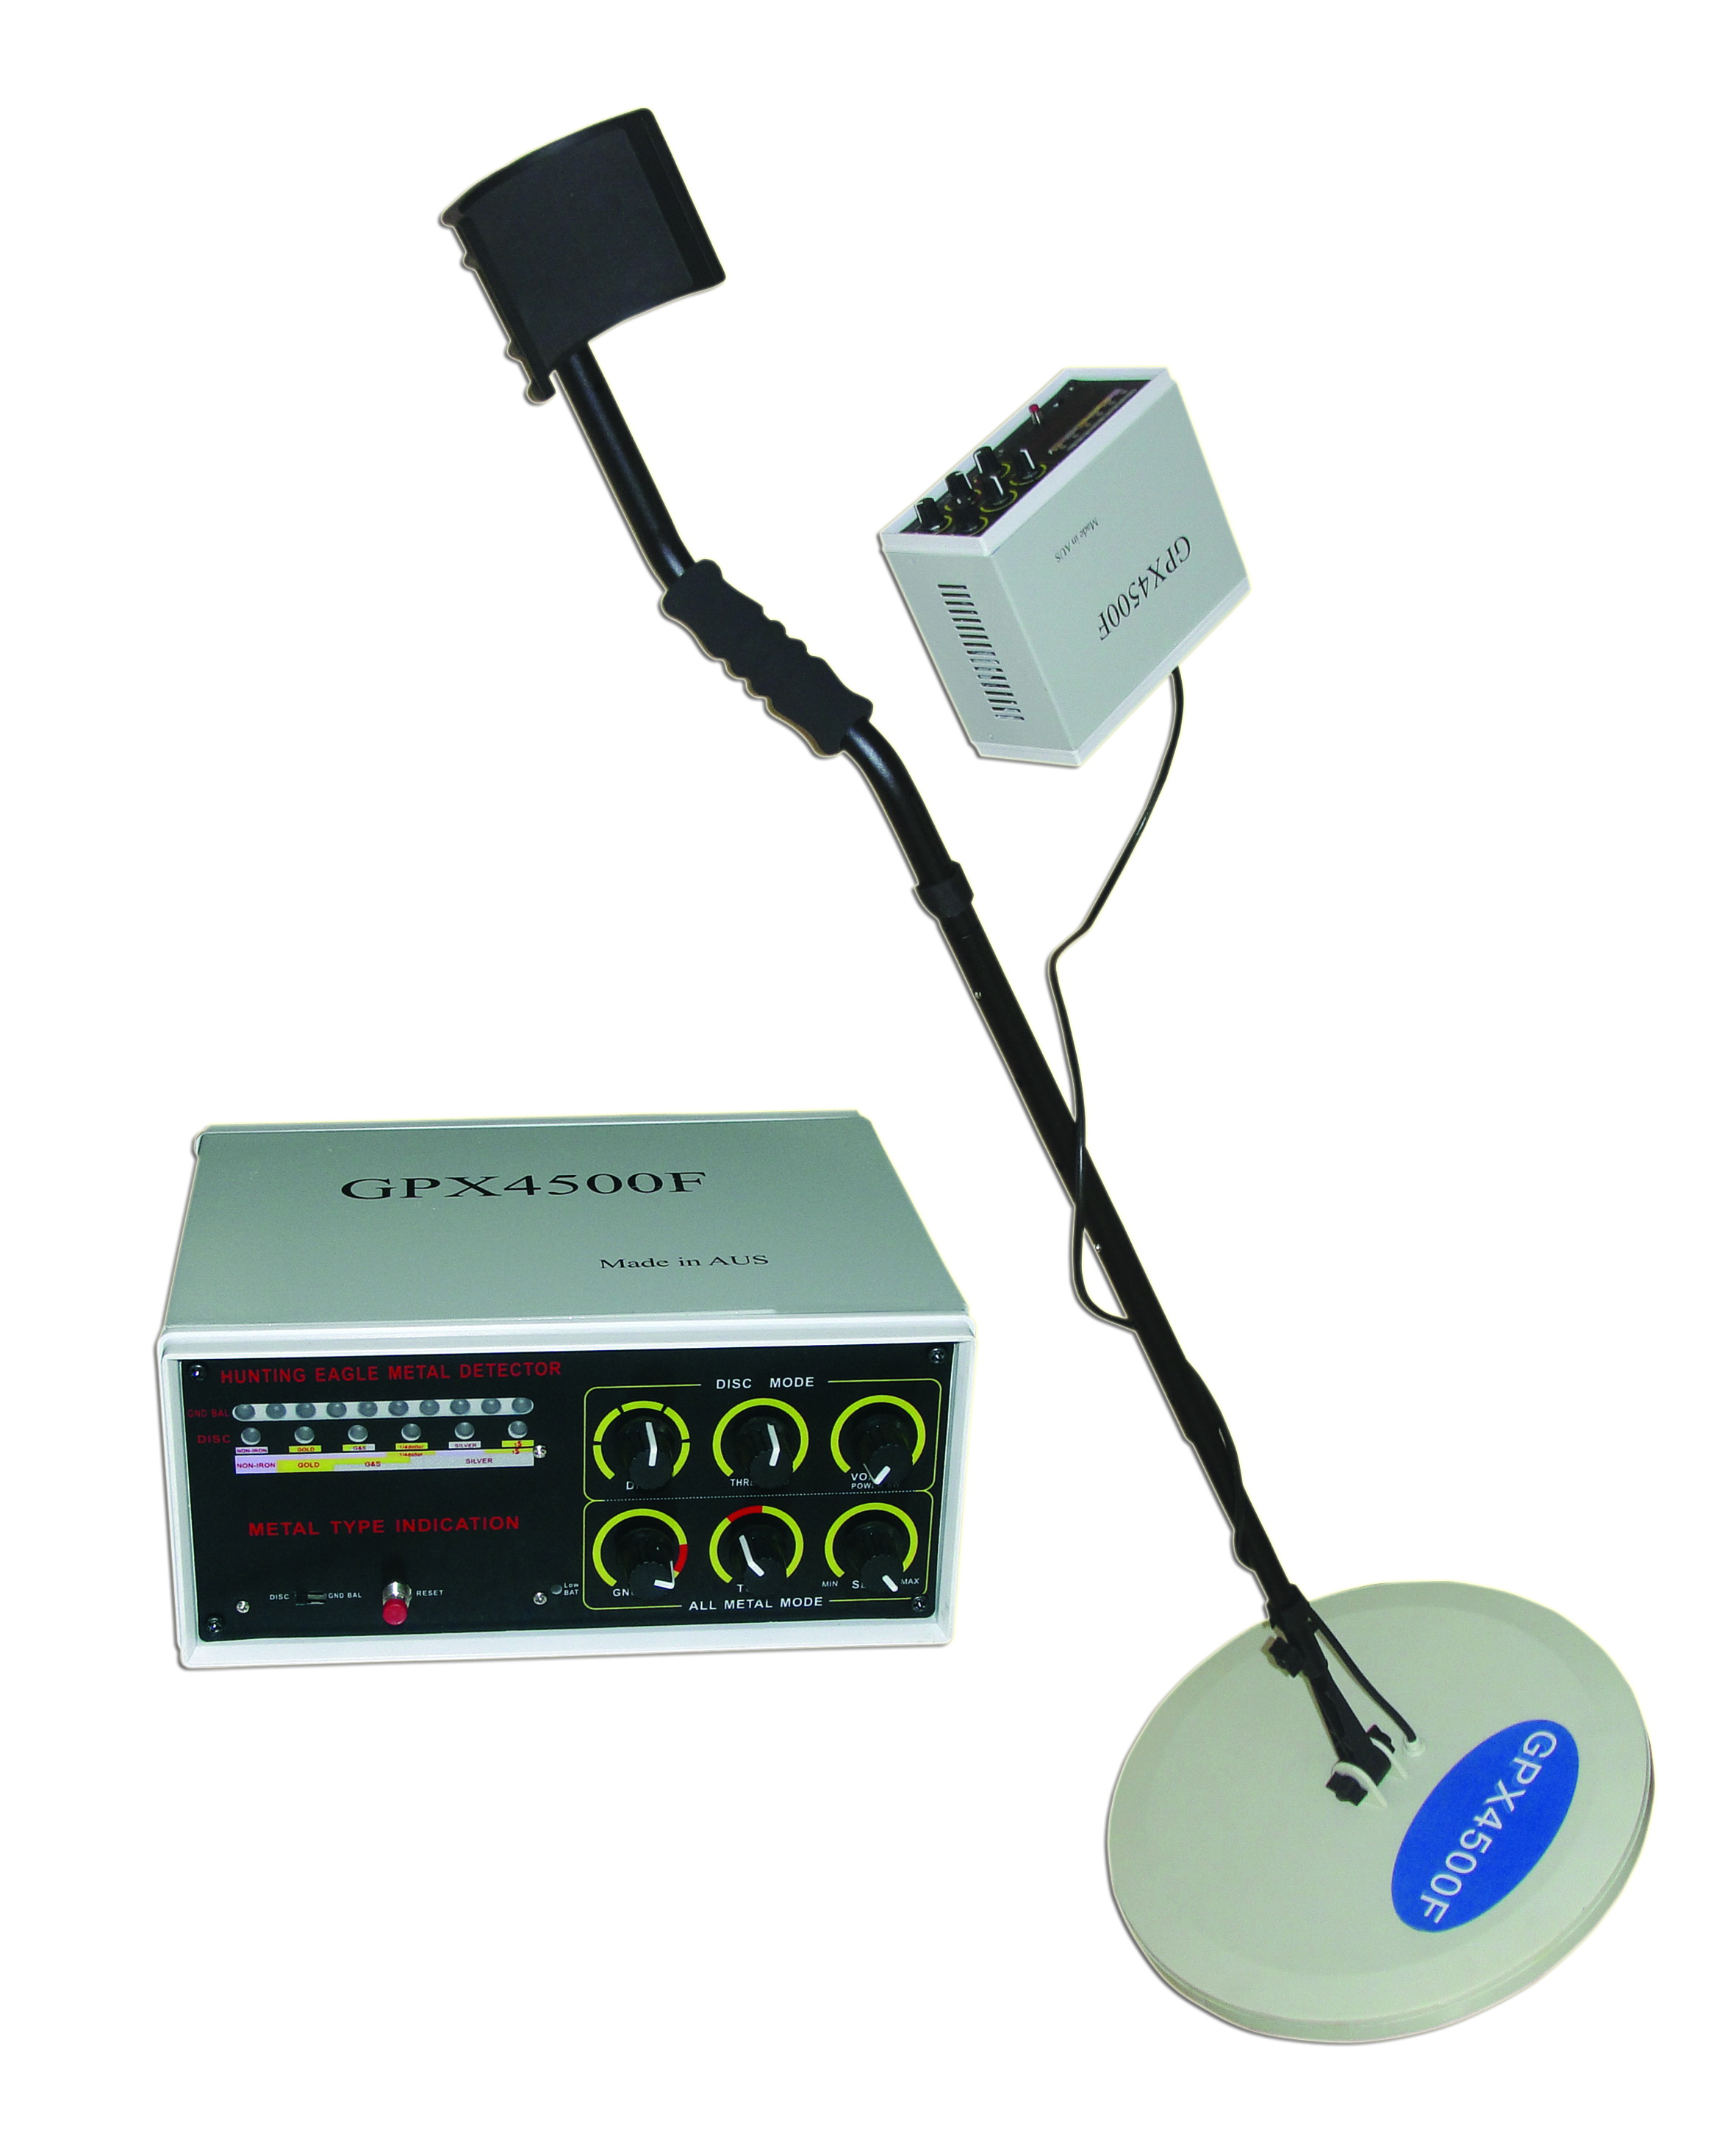

Please read the operating guide Before using this product, and properly kept for future inspection

Warranty
Replace the product within one month from the purchase date; due to the quality of the product itself, after the company confirmed, we will provide free one-year warranty period; for improper operation or man-made damage, our company can provide free repairs, but will received appropriate cost of materials,when rework the product you should attach your original purchase receipt. This warranty does not apply to the failure or defect caused by accident, improper use, improper maintenance, self-tamper machines and misuse of the machine, also does not apply to other contaminants and equipment repair made by non-authorized personnel .

Packing list
  - Detector Host
  - Host backpack
  - Waterproof probe set
  - A set of Detecting connection rod (3piece as a set)
  - Chargers
  - Headphones
  - Product manuals

specification
- Depth:2.5~3.5m
- Signal Frequency:9.6KHz
- Audio Frequency : 400Hz
- Power Supply:DC12V( Built-in rechargeable battery)
- Power Consumption:0.8W
- Connecting Rod Length: 1.3m
- Net Weight:2.4Kg
- Gross Weight:7Kg
- Package Size:60*42*16 CM
12
catalog
Features Description……………………………………….….2
Main Feature…………………………………………….…2
Structure Diagram………………………………………….…3
SETING-UP……………………………………………….….3
Function of Host Box………………………………….…4
Presentation of Headset Use…………………………….……6
Specific Operation Method Introduction……………6
Experience and Common Anomaly DetectionTips…9
LED Detection Instruction Panel……………………10
Testing and Use of Detectors…………………………10
Equipment Maintenance and Repair………………………..11
Warranty…………………………………………………...12
Packing List…………………………………………………12
Specification…………………………………….………12

1
Features Description:
GPX4500F is a high performance metal detectors, made by a strength of more than 10 years of professional detection equipment manufacturer .This detector’s sensitivity and stability enjoy the highest level among domestic products. In addition, The most prominent characteristics is that the type of metal can be identified, allowing you to easily find the available metal objects .which is the functions that other similar products are not available. You can go to more places to start treasure-hunting activities, search for coins, jewelry, gold and silver products with PALCON.

Main Feature:
1. High-brightness LED panel can generally displays the detected metal type according to the signal strength.
2. the all-metal detection mode is suitable for searching metal objects on the ground, and can be a simple recognition of metals
3. In addition to LED panel display, it can distinguish metal type by tones
4. 9.5-inch disk waterproof probe that can detect in the shallow water.
5. equipped with an external headphone jack ,connected to a single-channel headphones (headset-owned), easy to use; built-in high-capacity rechargeable battery, a low-voltage t function, with charger, Worked continuously for more than ten hours whenfull of power

2

2
Note: If you are using precious metals such as gold to do test items, remember that mark the location of placement in order to test finished back. Do not pile objects on the grass or weeds.
Detection Tips：
Do not swing like a pendulum as the probe. To bring the probe to detect otherwise, will appear wrong readings. Preferably from one side to the other side into a 15 cm wide, sweeping arc lateral move, to keep the probe in parallel with the ground. Moving slower sweep speed may be missing to detect targets.
Schematic diagram of plate movement detection method:
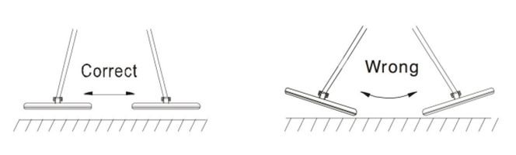

Equipment Maintenance and Repair:
GPX4500F Metal Detector is a well-designed, exquisite workmanship product, the following suggestions will help you maintain the product and improve the use life .
Operation of detectors should be careful and prudent. Fall can damage the circuit board and shell, and lead to abnormal working.
Should use the product In normal temperature environment,the cold or hot environment will shorten the life of electronic devices, and damage the detector shell
Away from dust and dirt, which can lead to corrosion and wear parts. Using damp cloth to keep its appearance as new regularly. Not use a chemical irritant cleaning products.
LED Detection Instruction Panel:
Instruction panel according to the U.S. standards for underground metal detector instructions mark. When the detector detects metal, the pointer will swing to the right. However, in the identification mode, the pointer will be directed out of the metal type detected. The metal panel arrangement is based on the metal conductivity, electrical conductivity. Metallic conductivity as possible, the greater the pointer area. Even if the same metal, LED signal strength will also be different. Because the deflection angle is also affected by the metal shape, size, and the burial depth of the impact. LED indicates that there is 5 degrees, 10 degrees, 20 degrees, 30 degrees, 40 degrees, 50 degrees, 60 degrees, 70 degrees, 80 degrees, 90-100 degrees 10 stalls distinguish the signal range corresponding to the light will turn on.
Testing and Use of Detectors:
In order to ensure that the detector is working properly to understand the metal detector response to different metals, you should test before the first use.
- Open the power switch into work mode.
- To find a surface without any metal area.
- On the ground you want to put a metal probe samples (such as a gold ring or a coin).
- Buttons to adjust the sensitivity and threshold to the middle position.
The probe 2-5 cm above the ground, slowly moving the probe where the sample area to be swept, swept from one side to the
other side should be.
four-degree is the instrument panel lights on the first four positions;identification button transferred to 4 degree,40 degree below on the dial(next to gold)is detected when the
10

structure diagram
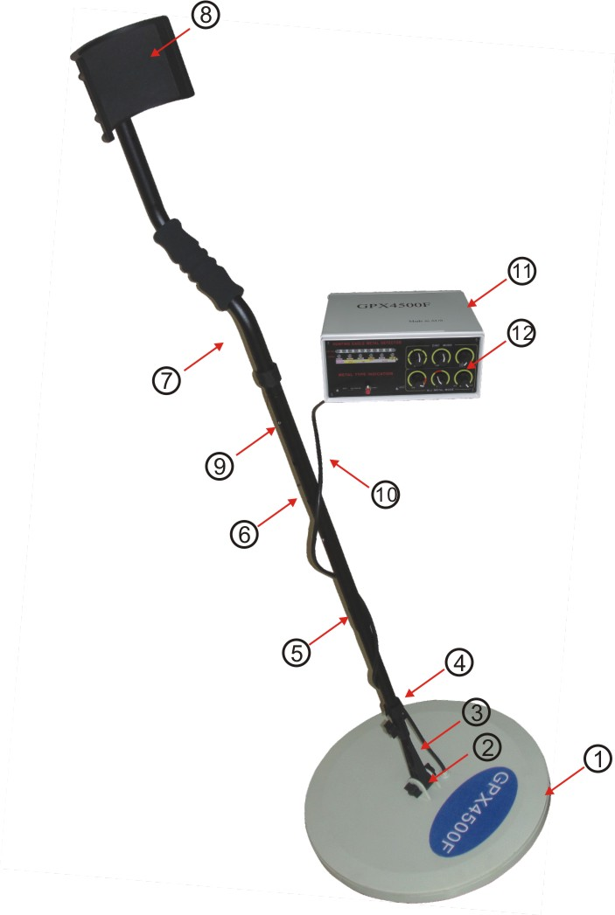

Figure 1

（1）Search ciol 2）Butterfly-shaped knob （3）probe connecting rod（4）Velcro 5）connecting rob 1 （6）connecting rob 2
（7）s-shaped connecting rob 8）arm cup （9）V-shaped clip
（10） Signal wire （11）host Box （12）host Operation panel
SETING-UP
Checking the seven components in packing carton: the host box, detecting disk, three pieces of combined telescopic rods, chargers, headsets. Then following the steps below:
- Take out the probe and the connecting rod 1, wring out one knob of connecting rod, remove the knob connector, and make connecting rod 1 insert into the probe rod, and then twisted tight knob fixed poles and probe.
3
- Take out the connecting rod 2 and S-tube, hold down the V-shaped clip buckle on the connecting rod 1, make connecting rod 1 insert into connecting rod 2; hold down the V-shaped clip buckle on the S-tube , then insert the other end of connecting rod 2 into S-tube, pay attention to ensure that the spring buckle card stuck in the pole mouth.
9
- Vertically stretch or shorten the proper length of the pole: holding the detector in relax, the distance between probe and ground is 1-2 inches . Can use the butterfly-shape knob to adjust parallel position between the probe and the ground. The probe cable can be wrapped around the pole by Velcro, pay attention to maintaining a certain degree of tightness.
- Make plug which is in the end of cable of Probe set insert into the air Socket on the host seat. Note: Please test the plug in place, hear the sound of carbazole,then screwe. Do not force avoiding damage.
Function of Host Box （Figure 2）
1.Detection signal indicative Zone
2. Ground Balance knob: All-metal mode button, P area is balanced block, in this area, the user can find a balance point
3.Tune knob: All-metal mode button, make the switch can be appropriated for all-metal mode (GND BAL), hold down the reset switch, when you rotate the knob to some point of the P block, the sound will be heard from the speakers, called the zero point of the voice community.
4.SENSITIVITY button: adjust the sensitivity of high or low, clockwise rotation can increase sensitivity, anti-clockwise rotation can reduce the sensitivity. This button applies to all-metal mode and identify mode.
5. DISC knob: Users can adjust this knob to exclude specific metal interference, that is, to detect the metal excluded there will not be sound alarm(namely distinguish Metal Type by tone)

alarm(namely distinguish Metal Type by tone)
4
For example:Identify the corresponding button on the four-degree is the instrument panel lights on the first four positions;identification button transferred to 4 degree,40 degree below on the dial(next to gold)is detected when the metal is not sound;However,more than 40 degrees will be issued a metals detected,"Du--Du"sound.
Experience and Common Anomaly Detection Tips:
If the detection area of interference, such as from other devices, power cable, television or radio station, to reduce sensitivity, or change to a detection zone.
Detection in high-mineralized region, even without the metal detector will be an audible alarm. At this point, you can reduce the sensitivity, threshold button and increase the distance between the probe with the ground until it can not hear the voice of misstatements.
In the soil composition of complex areas, the sensitivity needs to be transferred to the appropriate button and the threshold button position. Do not tune very high, otherwise there will be misstatement. Search, move away all the large pieces of metal and metal mining tools, to avoid interference.
In the all-metal mode, if the sensitivity of the high tone, alarm sound may change, this time, press the reset switch, to eliminate the interference, the indicator light reset, and then release the reset switch. In the recognition mode, to detect iron or alloy target, LED lights without any instructions, but if the goal is to iron foil, or foil, non-ferrous indicator light will turn on.

9
requires a lengthy experience to use and can accurately detect the object to determine what kind of metal objects generally belong to.
Instruction panel as shown below
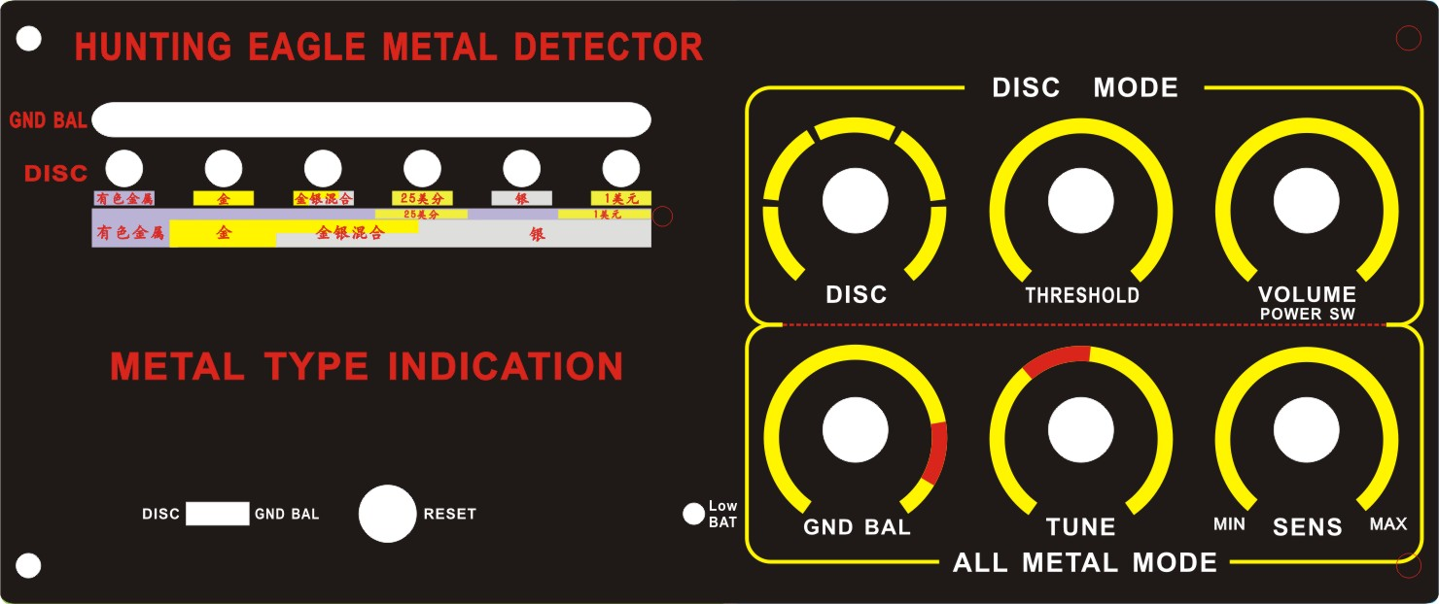

When find metal objects,the switch to identify the mode:will probe the mode switch to identify the mode of drawing,it will identify the threshold adjustment knob adjusted from 0 to 12 o'clock position,when the probe swept above the target,indicating plate the corresponding metal logo Department will light,in addition,you will hear a "drip--drop" sound.Detect various kinds of metal,indicating metal-board location of the corresponding logo Department will light.
Note：When it detects ferrous metals,the direct on-board without any instructions,if we find two metal targets,comparing the instructions at precious metals will be light,and some metal objects for containing a variety of metallic element composition,these elements will be identified at the same time light.Probe in a dark environment,you can identify the different voices to detect metal.At this point you can set the probe to the target precious metals issued a "drip--drop"sound,other metals are not sound.Identification button0--10 degrees,corresponding to dial the 0--10LED lights signal strength.
8
alarm(namely distinguish Metal Type by tone)
4
6.Threshold knob: This knob is only used to identify the recognition model, counter-clockwise rotation can reduce the interference, clockwise rotation can improve recognition sensitivity.
7. Volume knob: This knob has two functions, first is the power of the switching function, Also has the function of adjustment volume size in the recognition mode. clockwise rotation can increase volume, counterclockwise rotation can lower the volume, this knob does not apply to all-metal mode .
8. Low-voltage indicator (LOW BATT): when battery voltage is below 10V, the low-voltage indicator will be lit ,and users should recharge the battery in time
9. Reset Switch:when you should adjust Zero-point , make signal reset or remove interference Please Click here to reset.
10. Operating mode switch: GND BAL is the all-metal mode, DISC is metal recognition model
11. Headphone jack . Can be inserted 3.5 mm mono headset, then the built-in speaker will be disconnected at this time.
12.Charging interface: used for a built-in battery
13 Signal Interface: Connect the five core air head of the detection disk.

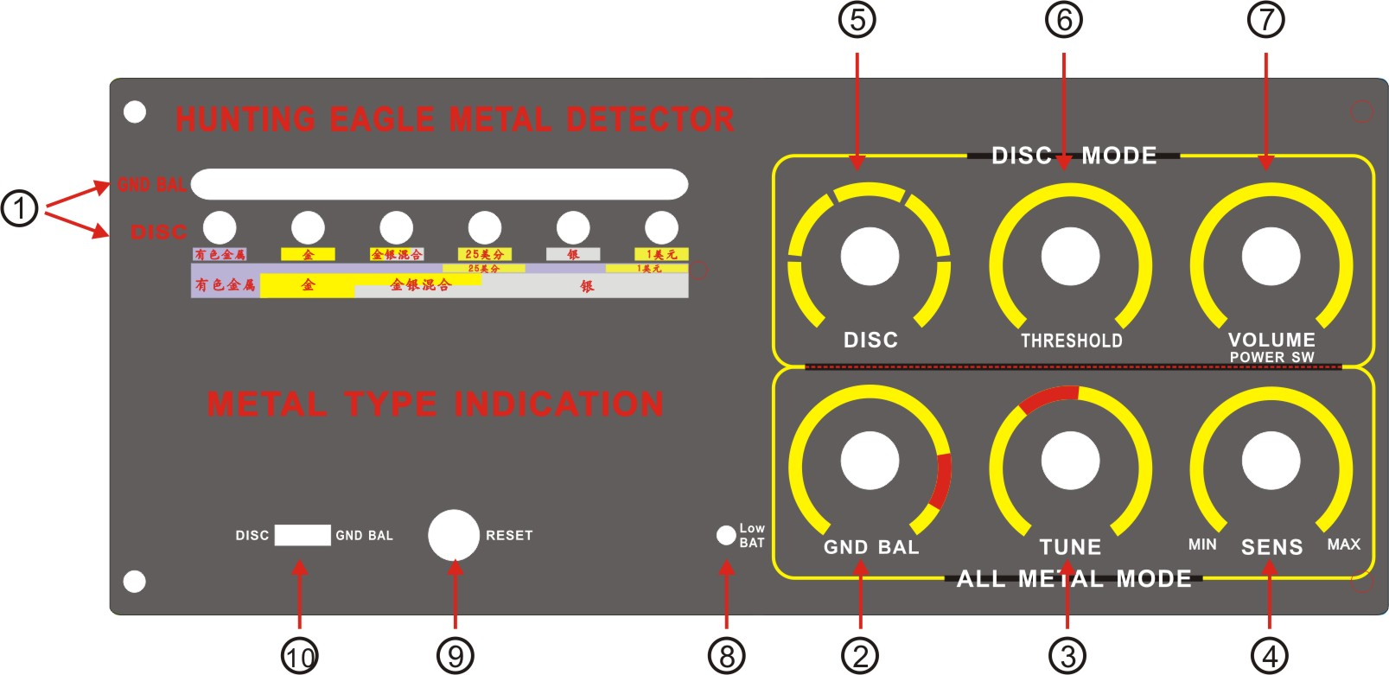

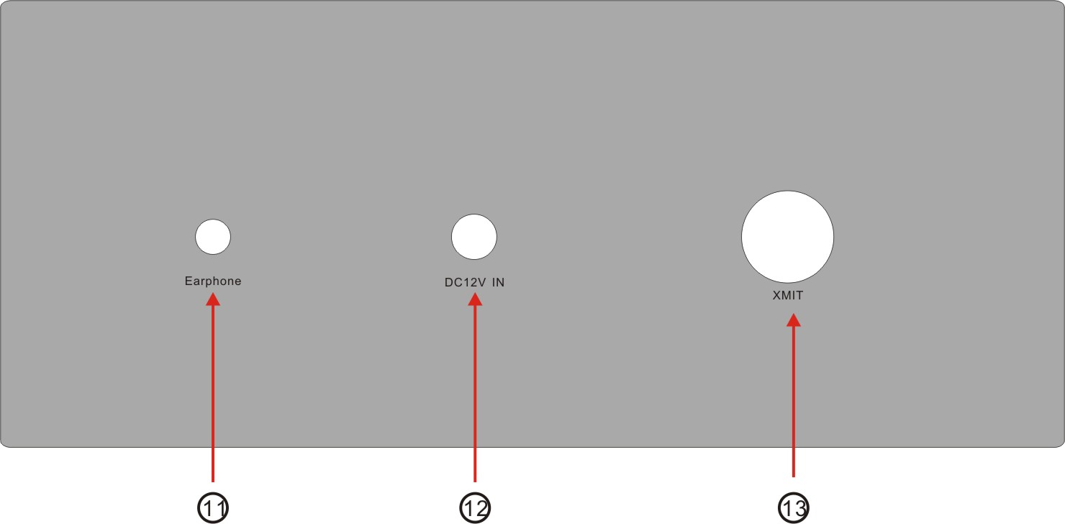

Figure 2
5
Pesentation of Headset use
  - plug The 3.5 mm stereo headphone into the headphone jack on the console box. At this point lounder speakers will ne disconnected.
  - Twist the volume knob (available in the DISC model) to reach the appropriate position.
  - Set DISC MODE. For your hearing safety , turn down the minimum volume, and then adjust the volume. Do not transfer to high volume, continuous listening too high may result in permanent hearing loss. Note traffic safety, do not use headphones in traffic-intensive areas
Specific Operation Method Introduction
1.All-metal model
- Select metal detector model:Detecting precious metals,first of all is to find metal,so the user should first make use of metal detection mode of operation is to take the operating mode switch to GND BAL model.
2、Zero-point adjustment.：Don't be set on the high sensitivity after power on.sensitivity⑦rotary knob to 12 o'clock position you can.The detectors mentioned,so that the probe with the ground distance of at least 1m,and then hold down the reset switch at the same time,tuning knob clockwise rotation⑥TUNE into the red zone until the speaker to hear the siren up.Zero-sector regulation and accurate or not will directly affect the detector sensitivity and stability.
3.Horizon Set:Regulate the zero point,and then release the reset switch,rotary balance button②to the P zone,the probe 2-5cm from the ground,you will hear zero point adjustment with the same alarm time.If the sound high,counter-clockwise rotation to balance button to lower
6
the sound;If the sound is too low,balance the knob clockwise to adjust to the appropriate intensity of the sound.Note:each of the adjustment to balance button,you need to press a reset switch until you hear the same siren.
4.Sensitivity Settings：The normal role of the sensitivity not to set too high,usually rotary knob④refers to 12o'clock position you can,each adjusted according to look after the sensitivity reset switch.Search in high-mining area.The sensitivity should be set lower,the distance between the probe and the ground should be higher,while the normal use,the probe 2-5cm away from the ground,slowly moving horizontal sweep can be.
5.Remove interference and reset operation：If the probe find any metal objects,you will hear the sound of an alarm,LED signal lights turn on and will accordingly;if you hear the different voices,and sirens were found during or in the detection of abnormal machine alarm when please press the reset switch,and then release the reset switch,and you'll hear with the zero point and the balance between the regulating profession is the same voice,began to repeat the operation until you adjust to the appropriate sound.If the alarm sound unusual,but the operation can not achieve the desired results,please turn off the power to re-operation again.
2.Identify patterns
Metal type available for direct panel description:
To detect ferrous metals,the panel does not have any instructions,DISC directed non-ferrous metals category article for instructions,the base of non-ferrous metals including gold,gold and silver mixture,25cents,silver,1 U.S.Dollars of several metal types,and sometimes the instruction on-board multiple instructions at the same time of light,indicating the target of the metal element content of more complex and
7

