PULSE AR Ⅳ

Country of Origin: Germany
User's Reference Manual

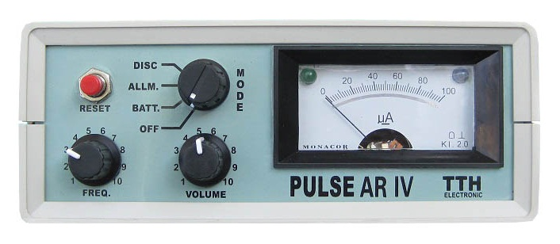

Product basic characteristics:
1 The maximum detection depth: 12 meters
2 Large detection range: it just takes 1 hours to complete the detection on a football field
3 Its detection can be free from the impact of the mineralization reaction and salts materials as long as you use the RESET button.
4. Its detection can identify the types of different metals

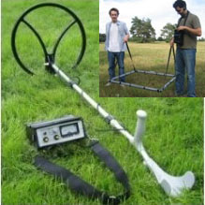
Technical parameters:
Volume: 198mm x 157mm x 62mm
Weight: 1100 grams (battery included)
Energy: 12v/2Ah
Operating hours: such energy can work for 10 hours
Charging time: 6-8 hours in quick charging mode
The use of main machine (Figure 1):
Various electronic components in the main machine coordinate each other in the rack with the stable quality, and four regulating buttons are installed on the surface of main machine.

Figure 1
RESET Operators should click this button to confirm when
after regulating other buttons or changing the location of detection disk or in the case of error signal
MOOD In the mode “OFF”, the machine is shut down.

Regulating to BATT, check the power situation of battery units, the meter readings will show the power supply situation battery units, indicating the status of the battery units and the power amount left.
Regulating to ALLM, the machine can detect any metal and will alarm when it encounters any metal.
Regulating to DISC, it can identify various kinds of metals, and the pointer on the meter head will point to different data for different metals.
FREQ Frequency modulator
VOLUME Regulating volume

Indicator light: After the DISC shift has captured the specific conductivity of object, when the indicator light just becomes bright, pointer points to a specific location, the type of metal can be known by operators. Indicator light and pointer will show the type of metal until the detection disk is removed from the above of metals.
The main machine is equipped with band for people hanging on the body to operate safely, so that operator doesn’t have to hold the machines with one hand.
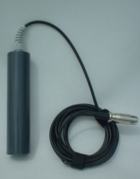
Figure 2
Conductive coil is applicable to be used in water bodies and closed caves and other closed environment (optional matching).

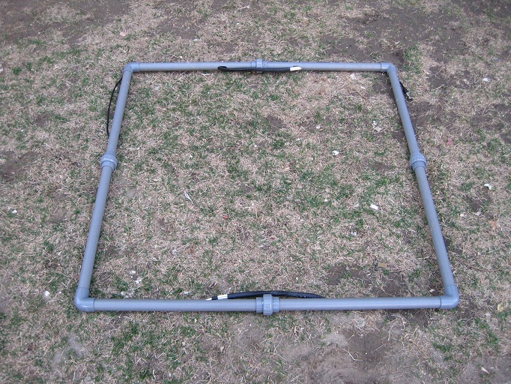
Figure 3
1 m * 1 m large detection disk is assembled by using eight plastic tubes.
The cable shall be firmly glued to the surrounding of detection disk, stick tightly with adhesive tape.
The detection disk shall be used by being placed in parallel with the ground and kept 2-5 centimeters above the ground (it will better if detection disk is being placed on the ground).
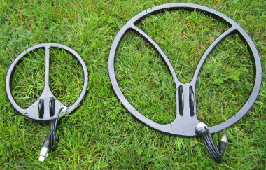
Figure 4
The radius of small detection disk is 45 cm, and it is used to detect medium-sized objects and suitable for medium to precise searching in the medium scope.
The detection disk is applicable to detect medium-size treasures with higher value, for example, Gold Ingots and the like objects.
The detection disk shall be used by being placed in parallel with the ground and kept 2-5 centimeters above the ground.
Regulate the detection disk to be 5 cm above the ground, and then press the RESET button for 3 seconds.
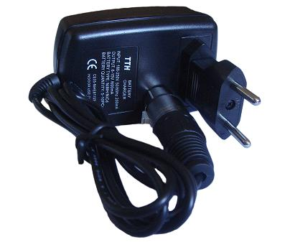
Figure 5
Voltage of charger (Figure 5) is 250 volts, and it can be connected to power supply with 180V-250V voltage for charging equipment.
The left Plug is used to connect to the main machine for charging equipment.
The right plug is used to connect to the power internal a car for charging equipment.

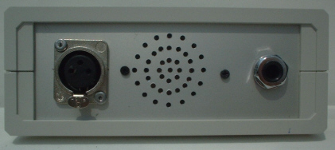

Figure 6
As shown in Figure 6, the left jack is not only used to connect the plug of detection disk and also it is used to connect the plug of charger, the right jack is used to connect the headphone plugs.
Detection method:
Before digging treasures, the following points must have been taken into account:
1 Frequency adjustment
2 Tone intensity
3 The duration of sound
4 The shift indicator
5 Conductivity data
In the detection, for the voice tone changes, the first signal indicates the existence of metal objects. Before the excavation, these factors should be taken into account, and also the work shall rely on personal experience.
In the detection, the stronger intensity of the tone, the greater the size of objects will be. The change in voice and the offset of pointer are simultaneous, so that people can more conveniently analyze and find out objects.
After the sound intensity and pointer offset have determined the size of objects, we may infer the shape of the objects through recognizing the conductivity of objects and identifying the specific types of metals.
If you want to identify the type of metal, it is necessary to select the DISC shift, after regulating frequency well again, press RESET button for 3 seconds, you can start the detection.
PULSE AR Ⅳ has the function of identifying metals and its built-in micro-processor can estimate the conductivity of metal, and thus it does not need rotating detection disc. Improvement in this area has a significant role in improving its detection depth.
In the detection, if the tone is very weak, then it can be ignored. Conductivity of metal is subject to estimation, which requires that it will let out a high intensity of pitch if a metal is detected. As long as the detection disk is just above the buried treasure, conductivity coefficient will be stored and displayed on the meter head.
We recommend that you had better first regulate it to ALLM shift in your detection until you can hear the stable tone with strong enough strength, and then regulate it to the DISC shift.
To keep the detection disk with a stable distance above the ground, and then press the RESET button for 2 seconds. Then please remove the detection disk and repeat the above actions until the strongest voices can be heard, DISC diode light will be bright, and the meter head will display the conductivity of metals.

To compare the instructions of metal conductivity data and the instructions of the metal value, its main purpose is to determine the type of metals.
The instruction of metal value implies the rough value of metal, you can judge through your own experience in detection.
For example, for a 10 cm * 10 cm iron plate, its value data is 40. A piece of gold, silver, copper plate(non-ferrous metals type) with the same size, display number of its value data will even lower, the data is around 20. Other types of metal will also have the corresponding data display. If object shape and size change, the value data displayed on meter head may also change. This is necessary to judge and determine by relying on your experience in detection.
Note: To ensure the correctness of the transmission data displayed, the RESET button will be pressed for more than 3 seconds whenever the shift is changed. AR-III has a the function of excluding small objects and specially detecting large objects, methods are as follows: detection disk and detection basket placed face-to-face the metal objects with specific area and then press the RESET button for 3 seconds or more, the instrument will memorize the size of the object and only detect objects larger than this area, objects smaller than this area will not be detected by the equipment.

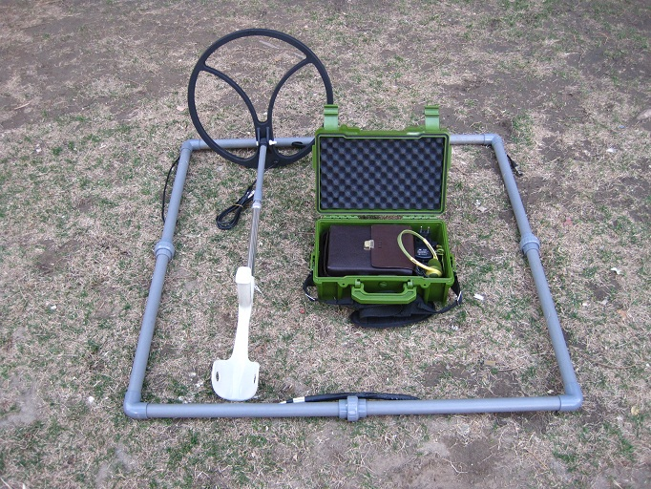

Identification of the error signal:
In the detection process, as a result of the diversity of regulators and filters, it will be interfered sometimes, and this interference will affect the equipment judging the value of the metal.
1. In the soil of magnetic oxides, the conductivity coefficient displayed in the meter head will be error.
2 A large block of iron will be mistaken for precious metals.
3. In order to determine the types of metal, metal size shall reach at least 5 cm * 5 cm
4. If two metals have approximate composition, then they may be mistakenly reported.
5. Radio transmission may also interfere with equipment.
6. Very strong magnetic field, in particular, the high-V antenna would interfere with the devices
Changes in the voice will first hint the existence of metal objects.
The stronger intensity of alarm sound, the greater volume of buried objects will be.
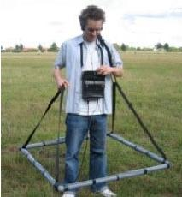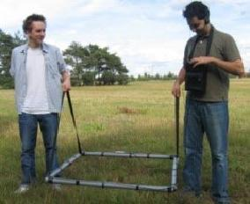

Attention items:
The apparatus is suitable for detecting the objects that are deeply buried and have large area in a very large scope.
If the object to be detected is very large, it is necessary to use the large detection disk; if the object to be detected has a small area, it is necessary to use the small detection disk.
Electricity power will be automatically regulated along with changes in the size of detection disk.
The instrument is equipped with conductive micro-processors, which can identify iron, gold and silver, and the like, and the different in data displayed by pointer on meter head indicates the specific types of metals.
If the objects have been buried for quite a long period, its detection depth will be increased 80% to the maximum extent.

